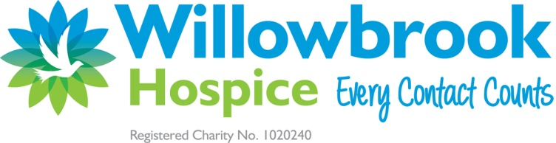

***Trustee Vacancies***

**Are you somebody with experience and knowledge of the charity sector?**

***Could you be a Trustee and support Willowbrook Hospice?***

Being a trustee is a great way of making a real difference to a charity. Trustees are volunteers who take on the responsibility to govern an organisation and then act collectively in its best interests. As a trustee you have the ultimate legal responsibility for directing the affairs of a charity and as such, play a key role in its growth and success.

At Willowbrook Hospice, the trustees are responsible for ensuring that the charity meets its stated purpose and aims, ensuring that it is both solvent and well run. So it isn’t always about what happens day to day; it is also about seeing and understanding the ‘bigger picture’.

***How do trustees make decisions?***

Board meetings are scheduled to take place no less than eight times a year, four of which are focussed on Assurance and Risk. Dates are circulated well in advance and there is an expectation that trustees attend all of these board meetings. Board meetings are planned to take place face-to-face, virtually via MS TEAMS but may also be a combination of both. Papers are sent to trustees in advance of each meeting which allows time for reading before the meeting to promote the opportunity for debate and decision. This collective decision making means that all trustees actively support the outcome of discussions, regardless of their individual views. It is then the responsibility of the Executive Management Team (EMT) to ensure the implementation of these decisions. The EMT consists of a Corporate Director, Clinical Director and Medical Director.

***Sub-groups***

The Board operates six sub groups, with specific Terms of Reference. These groups are chaired by a Trustee, focusing on key areas - Finance, HR, Digital and Technology, Income Steering, Clinical Assurance and Estates. Trustees are asked to serve on at least one sub group and attend regular meetings which are scheduled throughout the year.

Some specific tasks are delegated to smaller sub-groups that are held.

Willowbrook has undergone significant change in recent years and with post-pandemic reopening of our services and events, we have the need for regular advice and guidance on many different matters. Consequently, we have two vacancies on our Board of Trustees.

We are seeking to recruit two trustees with these specific skillsets:

1. A trustee with financial qualifications and significant experience infinance to complement the skills we currently have represented on our Board.
2. A trustee with knowledge and experience of hospice service provision; working with commissioners; grants committees; estates management.

*For further information and to arrange an initial conversation with our Chairman, please contact Catherine Hutton, Executive PA to the Executive Management Team:*

[CatherineH@willowbrookhospice.org.uk](mailto:CatherineH@willowbrookhospice.org.uk) or on 0151 430 8736

Closing Date: 28 February 2022